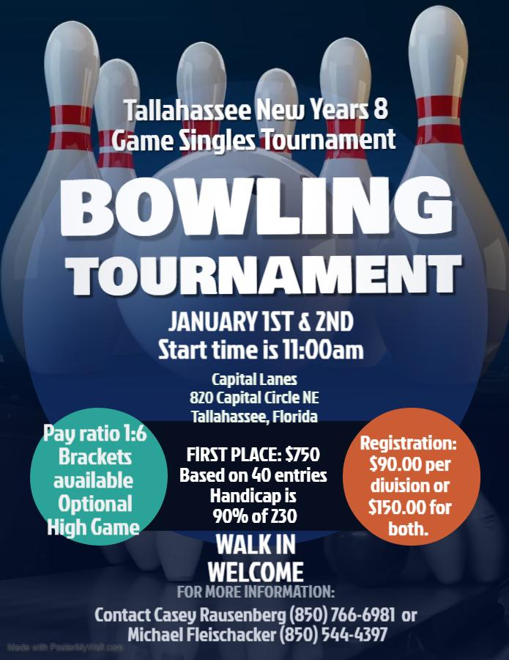
Tallahassee New Year’s 8 game singles sweepers tournament
January 1st & 2nd @ 11am
Name: ______________________________________________________________ Avg 20/21 ______________
Team captain: ________________________Email: _______________________phone #_(___)____-__________
- At Capital Lanes, 820 Capital Circle NE, Tallahassee, Florida
- $ 90.00 per bowler for either event or $150.00 for both.
- Format: 8 games moving one pair to the right after each game
- Handicap will be 90% of 230
- Please bring cash with you because A.T.M. might not be Available.
Please submit entries, questions, or concerns to Tournament director: Michael Fleischacker (850) 544-4397 or Casey Rausenberg (850) 766-6981
Mail entries to 1115 Rosewood Drive. Tallahassee, Florida 32301
Make checks payable to Michael Fleischacker
TOURNAMENT RULES
- This tournament is a sanctioned handicap invitational tournament open to all bowlers and have a USBC card at check in. Membership card can be purchased at the time of the event for $23.00. Violation of this rule will result in disqualification of the Individual. All entry fees and winnings will be forfeit and non-refundable. No Refunds shall be given after the entry fee has been confirmed. In addition to the rules below, USBC tournament rules will govern the operation of this tournament.
- The 10-pin rule is in effect as of January 1st 2021.
- Re-entries are allowed, but you can only cash once per event (handicap/scratch). Payout will be 1 in 6 after the 1st place guaranteed place is paid. If less, then 40 entries we will go 1 in 6 with no guarantee for 1st place. Guaranteed is only for the handicap entry. Scratch division will be 1 in 6.
- Bowlers will use one of the following averages:
  - Highest 2020-2021 USBC Book Average verified by book or on bowl.com. if none then
  - Highest Winter 2021/22 USBC average of 21 games or more if none then
  - If none of the above is available bowler must enter the tournament with a scratch average of 230.
- Entry fee is $90.00 for scratch or handicap ($60 P/F, $25 lineage, $5.00 expenses), or $150.00 for both scratch and handicap. There is no lineage for the second event entry of $60.00 ($55 P/F and $5.00 expense)
- Any player not present at the time the shift begins shall be considered late and will receive a 0 (zero) for each frame missed. A substitute will be permitted in case of injury provided his/her average can be verified by the tournament director. No absentee score will be used.
- Any protest affecting eligibility, scoring, or general playing rules must be specified, and must be submitted in writing to the tournament director before Prize Fund Payout. All tournament director decisions are final. Payout will occur within 30 days of the completion of the tournament.
- Entries will be accepted the day of the event if lanes are available. Tournament will offer: Scratch & Handicap brackets ($5.00 each) for Games 1,2,3. Games 4,5,6 and 6,7,8 and 50/50 raffle. All proceed from the tournament will help the Tallahassee Youth bowling program.

